Aim For the Flame
Salisbury Police Department - Special Olympics NC
Charity Match

Sponsored by USPSA NC Section
Presented by Outdoor Dynamics

June 20, 2026

Rowan County Wildlife Association
650 Majolica Road
Salisbury, NC 28147

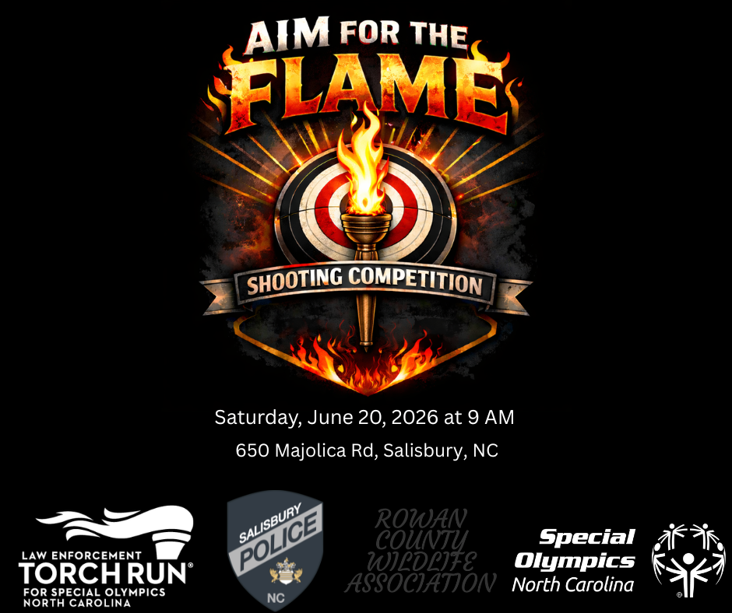
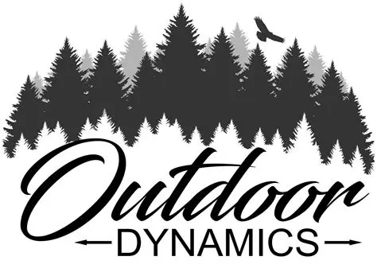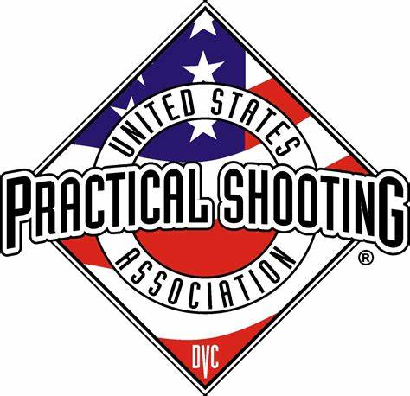

Contents
Sponsors 3
Title Sponsor 3
Presenting Sponsor 3
Stage Sponsors 4
Trophy Sponsors 5
Range Map 6
Range Facilities 7
Restrooms 7
Speed Limit 7
Parking 7
Spectators 7
Match Information 7
Match Book 7
Range Rules & Range Safety 7
Sanctioned Match 7
Lost Brass Policy 8
Walking Stages 8
Stage Inspection Policy 8
Registration and Match Fee Payment 8
Verification of Competitor Information 8
Match Schedule 8
Scoring 9
Match Results 9
Awards & Recognition 9
Squad Matrix 10
Match Staff 11
Stage 1 - Elevating Athletes 12
Stage 2 - Cultivating Potential 13
Stage 3 - Consistent Professionalism 14
Stage 4 - Make a Difference 15
Stage 5 - Eunice Kennedy Shriver 16
Stage 6 – The Power to Transform Lives 17

Sponsors

Title Sponsor

Presenting Sponsor


Stage Sponsors
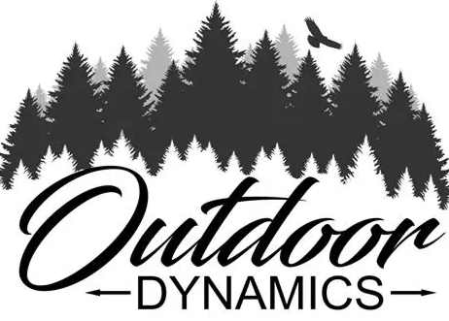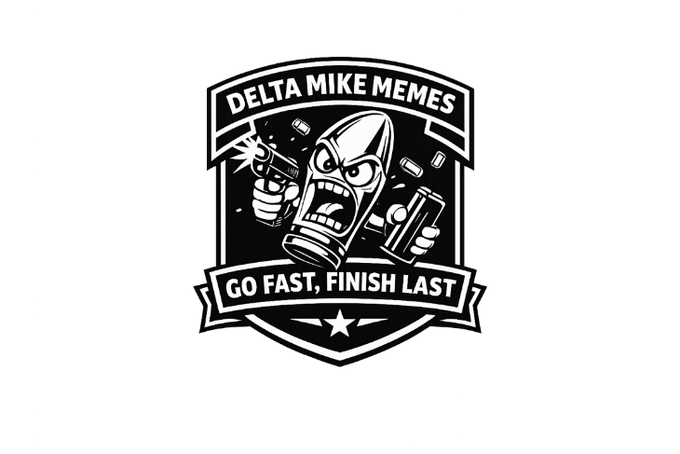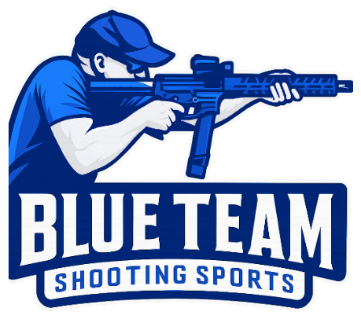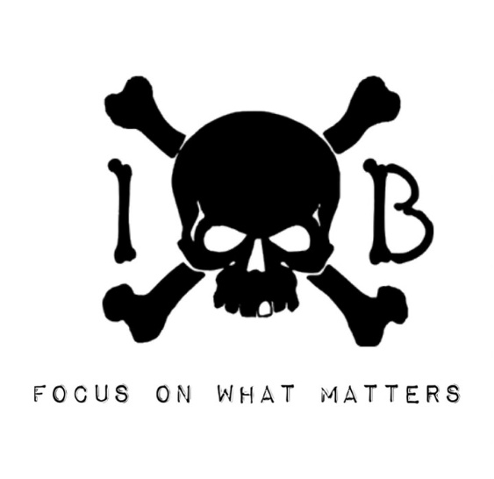
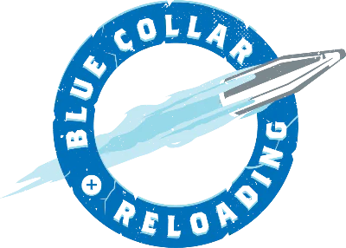

Trophy Sponsors
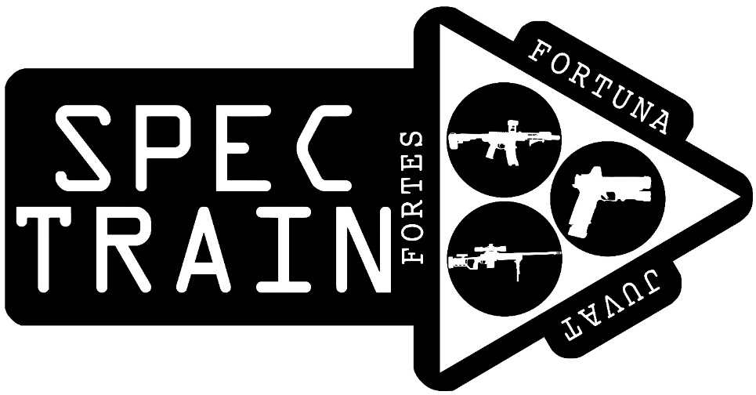
(Division Winners)

Dawn Perrot
(Category Winners)

Range Map

Rowan County Wildlife Association
650 Majolica Road
Salisbury, NC 28147
(Directions)

**5 MPH Speed Limit**

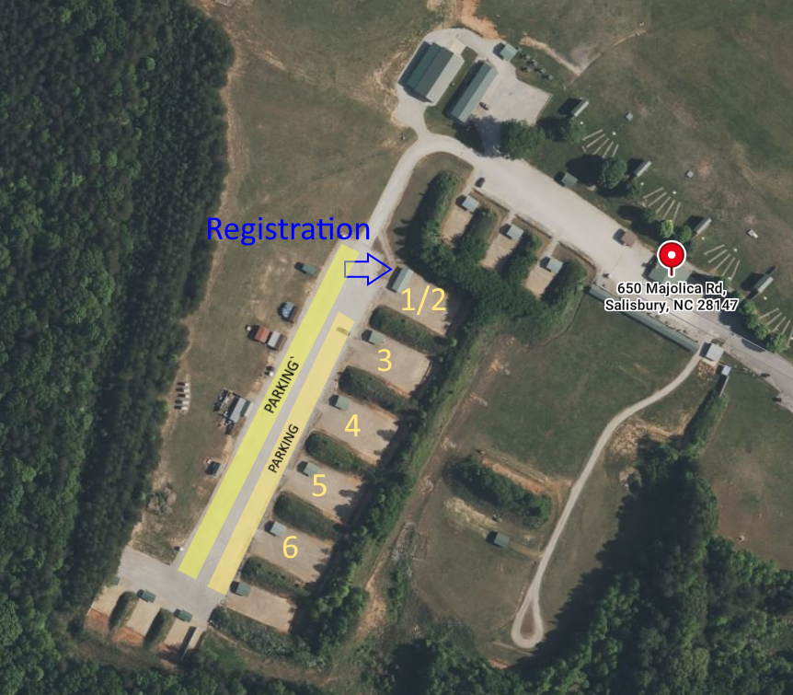

Range Facilities

Restrooms
Portable toilets are located throughout the range.

Speed Limit
Please observe the 5mph speed limit on the range.

Parking
Parking is permitted in the areas designated on the range map. Please DO NOT block entrances to the bays. When parking on the bay side of the lot, please leave plenty of room in front of your vehicle for competitors to pass.

Spectators
Spectators are welcome on the range. All spectators must have the appropriate eye and ear protection at all times. Children must be under the direct supervision of a parent or guardian at all times. No climbing on berms or props.

Match Information

Match Book
This match book is being offered to all competitors in a digital format. Printed copies will not be available at the range. This match book is subject to change up until the first shots fired.

Range Rules & Range Safety
Rowan County Wildlife Association is a COLD range during all shooting events. There shall be no handling of firearms unless you are in a designated Safety Area or under the direction of a Range Officer. Cars are not safe areas. All firearms must be in a bag, box, holster, etc. at all other times. No ammo, snap-caps, dummy ammo, etc. will be handled in the safe areas. There are no exceptions. Open containers of alcohol are not permitted on the range at any time.

Sanctioned Match
This match is a sanctioned Level I USPSA event. This match will operate under the rules published in the most recent edition of the USPSA Competition Handgun Rules. There will be no classifier stage.

Lost Brass Policy
All brass collected during this match will be distributed among the Range Officers as thanks for their hard work. Please do not collect your brass from the stages.

Walking Stages
Stages are considered closed and off-limits unless permission has been granted by the stage staff to walk the stage. In the event that the CRO/ROs are not present on the stage, the Range Master can also grant permission.

Stage Inspection Policy
Per rule 8.7.4, no person is permitted to enter or move through a course of fire without match staff present to supervise competitor actions during stage inspection unless the Range Master has specifically approved inspection of the stages with no staff present. Without match staff present or specific approval, the course of fire is to be considered closed or off limits. Altering stage props, targets or any other part of a COF without the approval of the Range Master is subject to the provisions in Section 10.6.

When a squad is assembled at the scheduled time, the stage briefing will be given followed by a four-minute inspection and question period. Only competitors at their scheduled stage may negotiate obstacles during the inspection period. The on-deck competitor alone may additionally negotiate obstacles, and only while the previous competitor’s targets are being scored. Early inspection of the stage is permitted by competitors, but only if a squad is not currently on the course of fire. Do not operate any of the moving targets or props. All props are off-limits at all times.

Registration and Match Fee Payment
Registration and match fee payment for all competitors will be done at Bay 1 (Stages 1/2). All competitors should check in and pay the match fee at registration prior to shooting. All squadding will have been completed online prior to the in-person registration process. The stats personnel will NOT be able to move any competitors to a different squad during the in-person registration process.

Registration Times
Saturday:
AM Squads: 9:00 AM - 10:45 AM
PM Squads: 1:00 PM – 1:30 PM

Verification of Competitor Information
It is the responsibility of the competitor to make sure that all registration information is correct before or at registration. If there are any mistakes, you must let the stats team know immediately at registration.

Match Schedule
Competitors must compete for score according to the published match and squadding schedule. Shoot through privileges can not be accommodated. A competitor who is not present at the scheduled time and date for any stage may not attempt that stage without prior approval of the Range Master. Failing to shoot a stage at the scheduled time will result in the competitor receiving a zero for that stage (6.5.1). Occasionally, stages will clear squads early. If an entire squad is present and all competitors and staff agree, the squad is permitted to start early.
Shooting Start Times
- Sat (AM) - 10:00 AM
- Sat (PM) - 1:30 PM

Scoring
The match will be paperless. Scores will be recorded on tablets. The competitor or their designee must press the “Approve” button on the tablet. Rule 9.7.3 will be enforced, if needed, to ensure match integrity is upheld.

Match Results
Unofficial match results will be posted to the Practiscore website periodically throughout the match. Final (official) match results will be posted to the USPSA website.

Per 9.8.3, if a competitor detects an error in the provisional results at the end of the match, they can file an appeal with the Stats Officer no later than 1 hour after the results are posted. If the appeal is not filed within 1 hour, the appeal will be dismissed.

Awards & Recognition
The winner of each division with at least 5 competitors will be recognized with a trophy provided by SPECTRAIN.

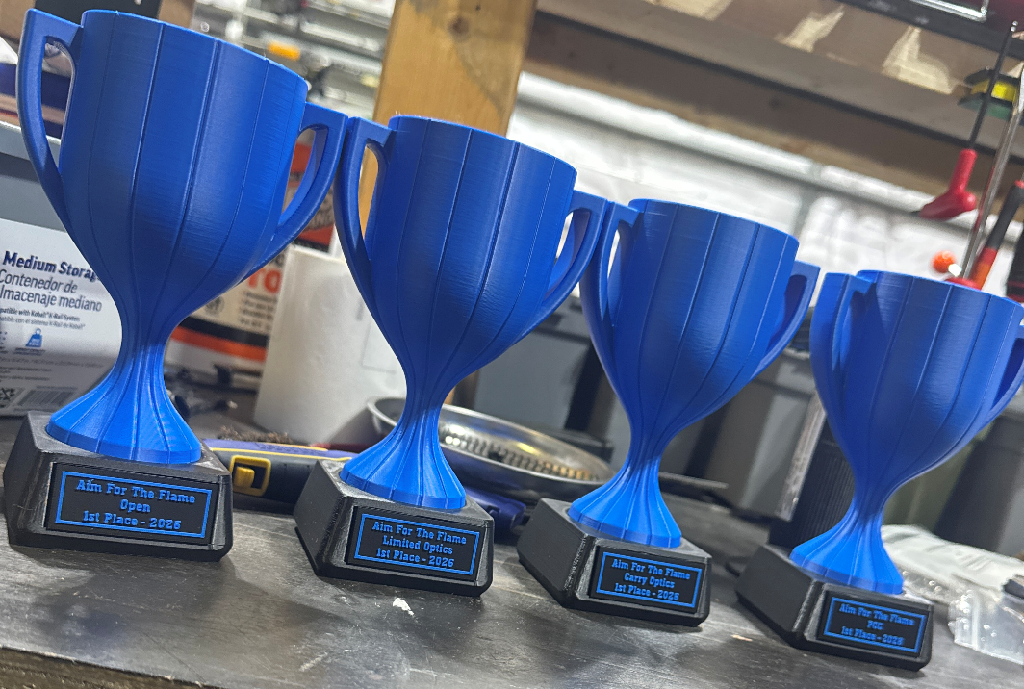

Squad Matrix
 |  |  | AM
7:00 AM |  |  | Setup
 | Bay 1 | Bay 2 | Bay 3 | Bay 4 | Bay 5
10:00 AM | 101 | 102 | 103 | 104 | 105
10:35 AM | 105 | 101 | 102 | 103 | 104
11:10 AM | 104 | 105 | 101 | 102 | 103
11:45 AM | 103 | 104 | 105 | 101 | 102
12:20 PM | 102 | 103 | 104 | 105 | 101
12:55 PM |  |  | Lunch
 |  |  | PM
 | Bay 1 | Bay 2 | Bay 3 | Bay 4 | Bay 5
1:30 PM | 201 | 202 | 203 | 204 | 205
2:22 PM | 205 | 201 | 202 | 203 | 204
3:14 PM | 204 | 205 | 201 | 202 | 203
4:06 PM | 203 | 204 | 205 | 201 | 202
4:58 PM | 202 | 203 | 204 | 205 | 201
5:50 PM |  | Tear |  | Down

Match Staff

This match would not be possible without the tireless dedication of our volunteers.
Please take a moment during the match to thank the volunteers below.

Match Director | Ike Starnes | Range Master | Ike Starnes
Stats | Dan Doiron | Mr. Fix It | Aaron Banks / Juan Urquiza
Section Coordinator | Allen Terrell | Photographer | Your Squadmates
Stage Designers  John Royer  Ryan Christenson  Rocky Perillo  Ike Starnes  Kyle Narkum | Stage 1/2  Ike Starnes  Aaron Banks | Stage 3  David Burton  Sebastian Yordan | Stage 4  Rocky Perillo  Ryan Christenson
 | Stage 5  Keith Nagelski  Adam Taylor | Stage 6  Jamar Yeadon  James Garrett
Setup Crew
John Royer  Warren Falcone  Adam Taylor  Juan “Wick” Urquiza | Ike Starnes  Aaron Banks  Keith Nagelski | David Burton  Ryan Christenson  Jamar Yeadon | Rocky Perillo  Sebastian Yordan  James Garrett

Stage 1 - Elevating Athletes
COURSE DESIGNER: Rocky Perillo
START POSITION: Anywhere inside the shooting area
READY CONDITION:  Handgun loaded and holstered, wrists below belt.  PCC loaded, held in both hands, stock touching belt. | TARGETS: 8 USPSA  SCORED HITS: Best 2 hits  ROUNDS: 16  SCORING: COMSTOCK
STAGE PROCEDURE: On the audible start signal, engage all targets from within the shooting area.
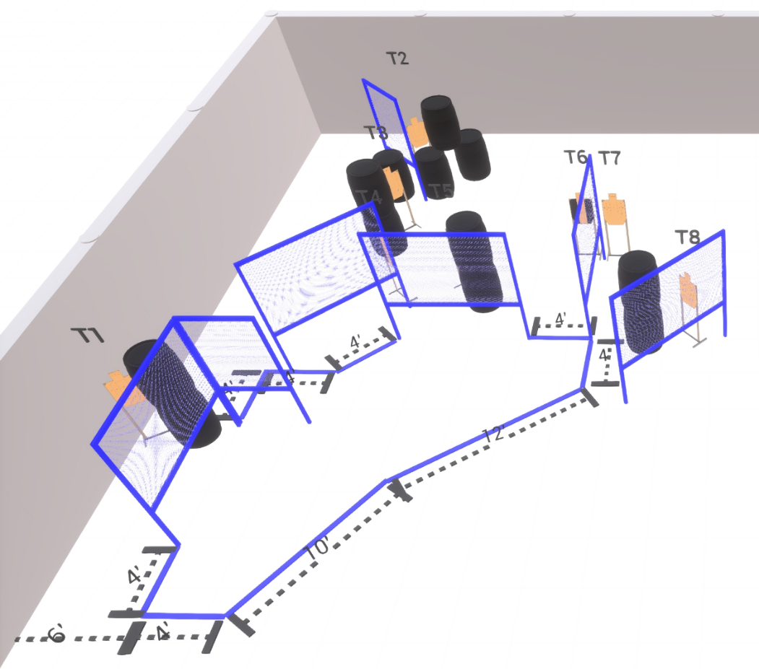
Sponsored By
IBX Tactical
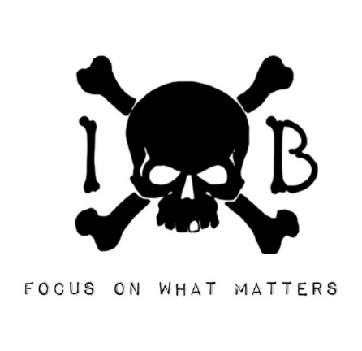

Stage 2 - Cultivating Potential
COURSE DESIGNER: Rocky Perillo
START POSITION: Feet straddling start stick with toes touching rear fault line
READY CONDITION:  Handgun loaded and holstered, wrists below belt.  PCC loaded, held in both hands, stock touching belt. | TARGETS: 7 USPSA  SCORED HITS: Best 2 hits  ROUNDS: 14  SCORING: COMSTOCK
STAGE PROCEDURE: On the audible start signal, engage all targets from within the shooting area.
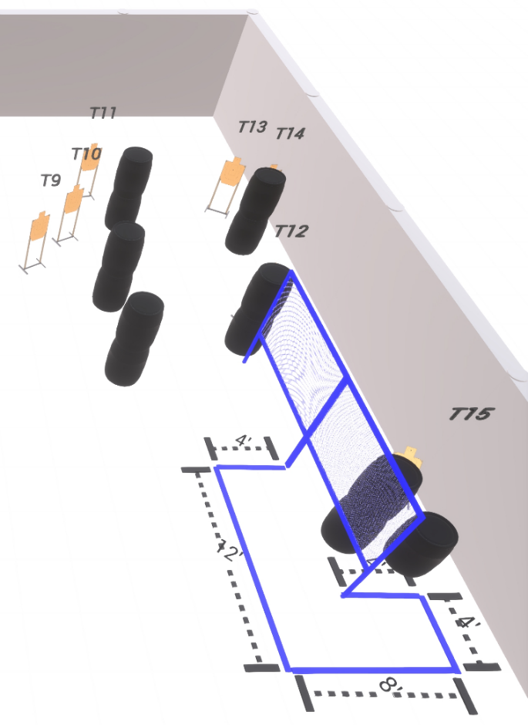
Sponsored By

Stage 3 - Consistent Professionalism
COURSE DESIGNER: John Royer
START POSITION: Both feet on Xs
READY CONDITION:  Handgun loaded and holstered, wrists below belt.  PCC loaded, held in both hands, stock touching belt. | TARGETS: 13 USPSA  SCORED HITS: Best 2 hits  ROUNDS: 26  SCORING: COMSTOCK
STAGE PROCEDURE: On the audible start signal, engage all targets from within the shooting area.
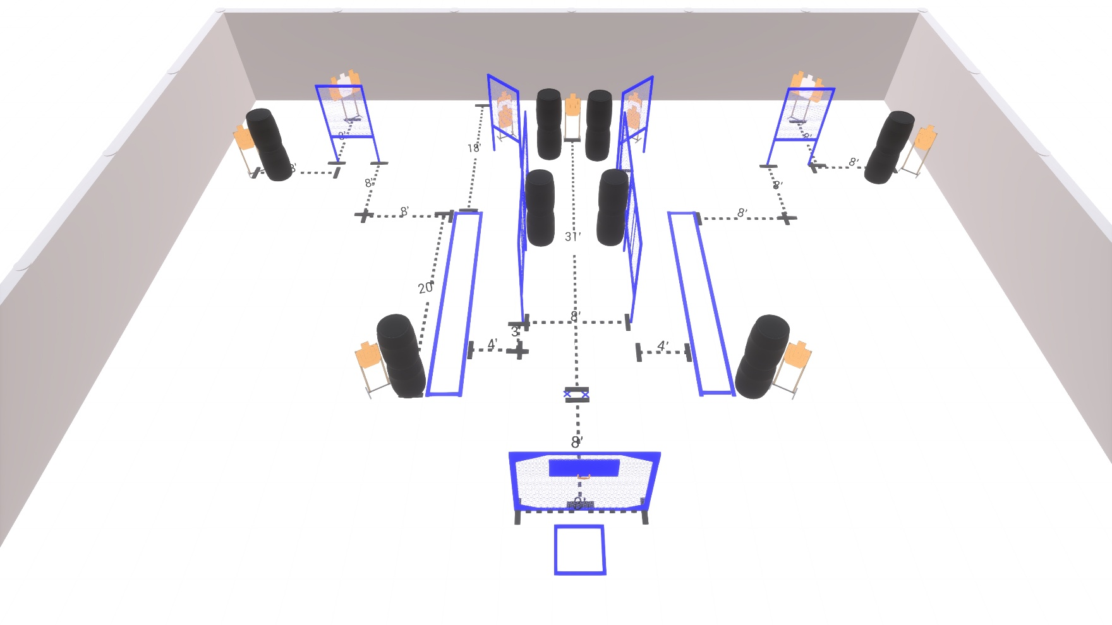
Sponsored By
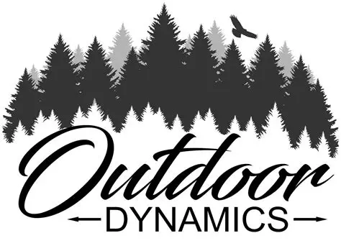

Stage 4 - Make a Difference
COURSE DESIGNER: John Royer / Kyle Narkum
START POSITION:
Inside the shooting area.

READY CONDITION:  Handgun loaded and holstered, hands touching marks.  PCC loaded, held in both hands, muzzle touching mark. | TARGETS: 14 USPSA Cardboard, 2 USPSA Poppers  SCORED HITS: Best 2 hits  ROUNDS: 30  SCORING: COMSTOCK
STAGE PROCEDURE: On the audible start signal, engage all targets from within the shooting area.

Swinger is activated by Popper 2 and remains visible at rest.
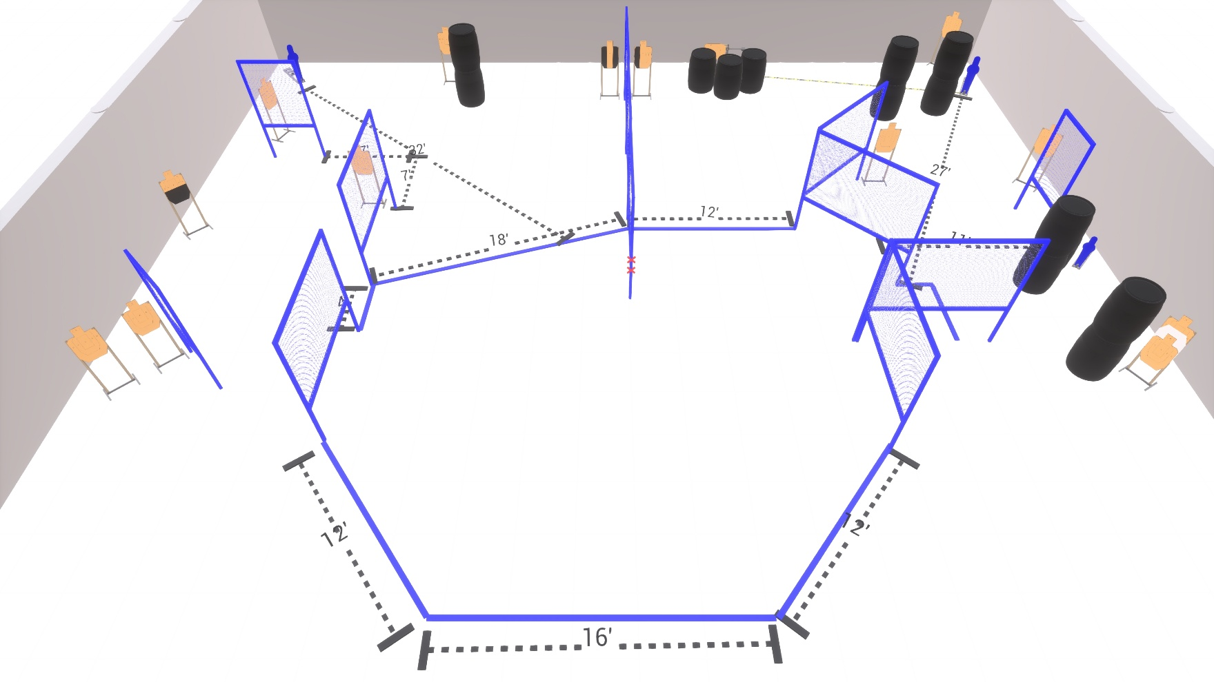

Sponsored By

Stage 5 - Eunice Kennedy Shriver
COURSE DESIGNER: Ryan Christenson
START POSITION: Both feet on the Xs.
READY CONDITION:  Handgun loaded and holstered, wrists below belt.  PCC loaded, held in both hands, stock touching belt. | TARGETS: 12 USPSA cardboard targets, 6 steel targets  SCORED HITS: Best 2 hits on static cardboard. Best 4 hits on max trap  ROUNDS: 32  SCORING: COMSTOCK
STAGE PROCEDURE: On the audible start signal, engage all targets from within the shooting area.
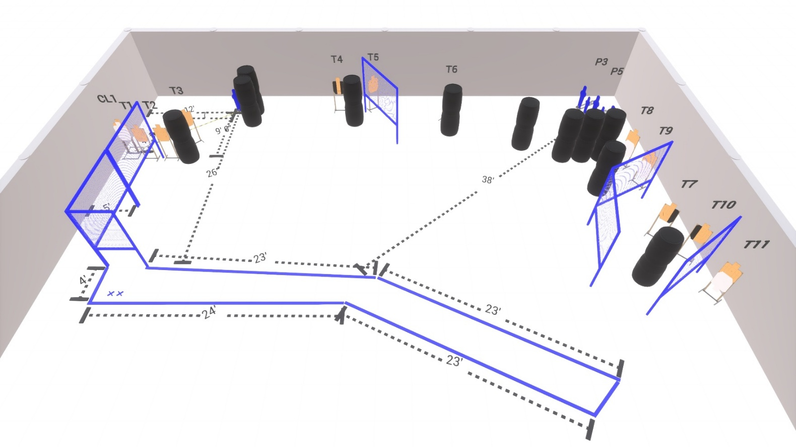

Sponsored By
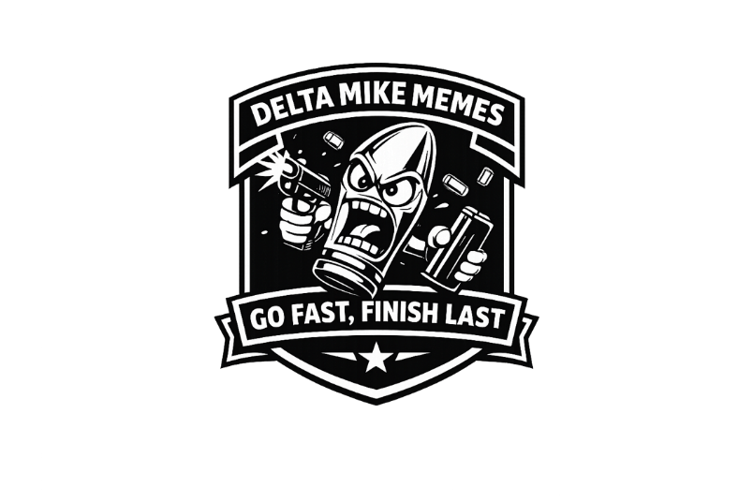

Stage 6 – The Power to Transform Lives
COURSE DESIGNER: Ike Starnes
START POSITION: Anywhere inside the shooting area.
READY CONDITION:  Handgun loaded and holstered, wrists below belt.  PCC loaded, held in both hands, stock touching belt. | TARGETS: 12 USPSA cardboard, 4 USPSA Poppers, 1 Steel NS  SCORED HITS: Best 2 hits  ROUNDS: 28  SCORING: COMSTOCK
STAGE PROCEDURE: On the audible start signal, engage all targets from within the shooting area.
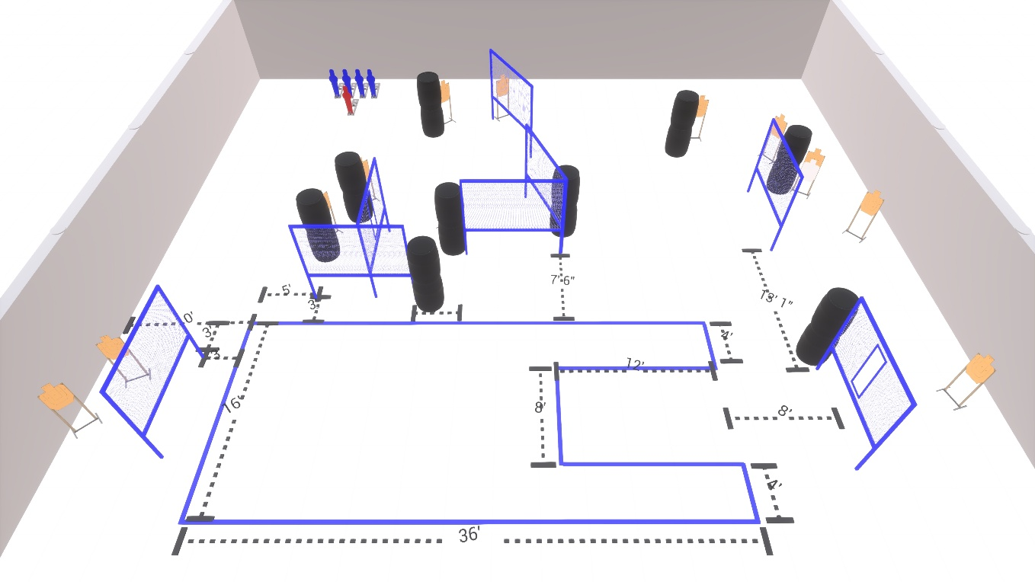

Sponsored By


